

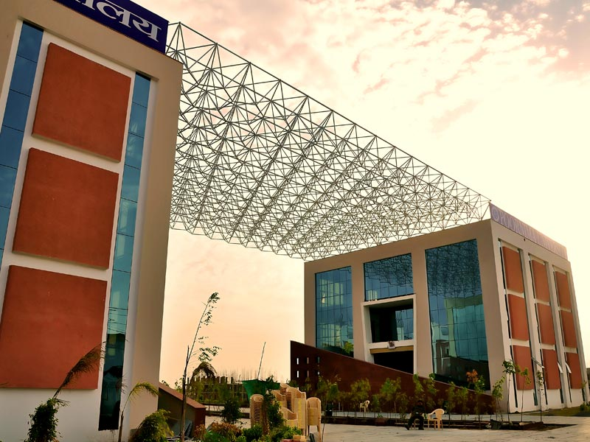

**SCHOOL OF BASIC & APPLIED SCIENCES**

**DEPARTMENT OF COMPUTER APPLICATION**

**TEACHING SCHEMES**

**Bachelor of Computer Applications**

**BCA (Batch 2015-18)**

|  |  |  |  |  |  |
| --- | --- | --- | --- | --- | --- |
| **POORNIMA UNIVERSITY** | | | | | |
| **Bachelor of Computer Applications (Batch 2015-18)** | | | | | |
| **First Year - First Semester** | | | | | |
| **Subject Code** | **Subject Name** | **Teaching Scheme (Hrs per week)** | | | **Credits** |
| **Lec (L)** | **Tut (T)** | **Prac (P)** |
| **A.** | **Core Subjects (Theory)** |  |  |  |  |
| BCA01101 | Office Automation Tools | 4 | - | - | 4 |
| BCA01102 | English I | 4 | - | - | 4 |
| BCA01103 | Fundamentals of Mathematics | 4 | - | - | 4 |
| BCA01104 | Computer Fundamentals & Organization | 4 | - | - | 4 |
| BCA01105 | Programming in C | 4 | - | - | 4 |
| BCA01106 | Principles of Programming Languages | 4 | - | - | 4 |
| **B.** | **Departmental Elective (Theory) : ANY ONE** | | | | |
|  | - | - | - | - | - |
| **C.** | **Practicals** | | | | |
| BCA01207 | C Programming Lab | - | - | 4 | 2 |
| BCA01208 | Office Automation Tools Lab | - | - | 2 | 1 |
| BCA01209 | Soft Skills-I | - | - | 2 | 1 |
| **D.** | **Project/Seminar** |  |  |  |  |
|  | - | - | - | - | - |
| **E.** | **Programmes / Activities** |  |  |  |  |
| BCA01610 | **Discipline and Talent Enrichment Programme (TEP) - I** |  |  |  | **2** |
| BCA01610.1 | Effective Speaking and Analytical Skills - I | 2 | - | - | - |
| BCA01610.2 | Online Eligibility Exam (OLE) | 1 | - | - | - |
| BCA01610.3 | Programming Demonstrations | 1 | - | - | - |
| BCA01610.4 | Domain-level Tutorials | 1 | - | - | - |
| BCA01610.5 | Research and Presentations | 2 | - | - | - |
|  | **Total** | **31** |  | **8** | **30** |
|  | **Total Teaching Hours** | **39** | | |
|  |  |  |  |  |  |

|  |  |  |  |  |  |
| --- | --- | --- | --- | --- | --- |
| **POORNIMA UNIVERSITY** | | | | | |
| **Bachelor of Computer Applications (Batch 2015-18)** | | | | | |
| **First Year - Second Semester** | | | | | |
| **Subject Code** | **Subject Name** | **Teaching Scheme (Hrs per week)** | | | **Credits** |
| **Lec (L)** | **Tut (T)** | **Prac (P)** |
| **A.** | **Core Subjects (Theory)** |  |  |  |  |
| BCA02101 | Discrete Mathematics | 4 | - | - | 4 |
| BCA02102 | English II | 4 | - | - | 4 |
| BCA02103 | Internet and Web Designing | 4 | - | - | 4 |
| BCA02104 | OOPS with C++ | 4 | - | - | 4 |
| BCA02105 | Data Structures using C | 4 | - | - | 4 |
| BCA02106 | Computer Architecture | 4 | - | - | 4 |
| **B.** | **Departmental Elective (Theory) : ANY ONE** | | | | |
|  | - | - | - | - | - |
| **C.** | **Practicals** | | | | |
| BCA02207 | OOPS with C++ Lab | - | - | 4 | 2 |
| BCA02208 | Data Structures Lab | - | - | 4 | 2 |
| BCA02209 | Web Designing Lab |  |  | 2 | 1 |
| BCA02210 | Life and Career Skills | - | - | 2 | 1 |
| **D.** | **Project/Seminar** |  |  |  |  |
|  | - | - | - | - | - |
| **E.** | **Programmes / Activities** |  |  |  |  |
| BCA02611 | **Discipline and Talent Enrichment Programme (TEP) - II** |  |  |  | **2** |
| BCA02611.1 | Online Eligibility Exam (OLE) | 1 | - | - | - |
| BCA02611.2 | Domain-level Tutorials | 1 | - | - | - |
| BCA02611.3 | Effective Speaking and Analytical Skills - II | 1 | - | - | - |
|  | **Total** | **27** |  | **12** | **32** |
|  | **Total Teaching Hours** | **39** | | |
|  |  |  |  |  |  |